**Madiha Aimon Tappal**

[madihaaimon@gmail.com](mailto:madihaaimon@gmail.com)

**Data Engineering Batch – 1**

**Day – 23 Assignment**

**Azure Databricks**

**What is Azure Devops?**

Azure DevOps is a suite of tools that helps organizations deliver software faster and with more quality. It provides a comprehensive set of features for version control, continuous integration and continuous delivery (CI/CD), build automation, testing, and release management.

[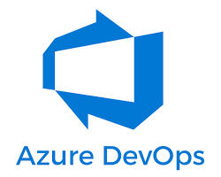 w](https://medium.com/featurepreneur/what-is-azure-devops-863698ae986f)

Azure DevOps logo

Here are some of the key benefits of using Azure DevOps:

* **Improved collaboration:** Azure DevOps provides a central platform for developers, testers, and operations teams to collaborate on software development. This helps to break down silos and improve communication between teams.
* **Faster software delivery:** Azure DevOps automates many of the tasks involved in software development, such as building, testing, and deployment. This can help organizations to deliver software faster and more frequently.
* **Higher quality software:** Azure DevOps provides tools for continuous testing and integration, which can help to identify and fix bugs early in the development process. This can lead to higher quality software releases.
* **Reduced costs:** Azure DevOps can help organizations to reduce costs by automating tasks and improving efficiency.

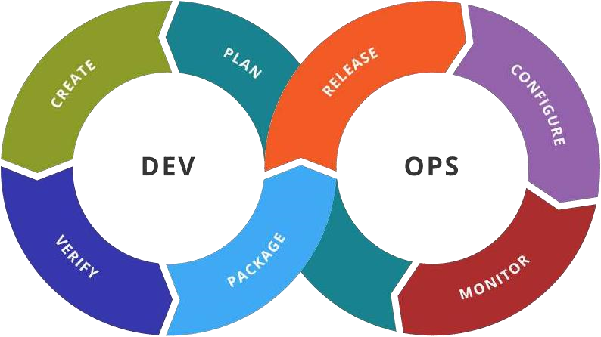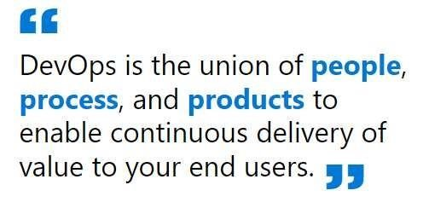

* **Increased agility:** Azure DevOps can help organizations to be more agile and responsive to change. This is because it provides tools for continuous integration and continuous delivery, which allows organizations to quickly release new features and updates.

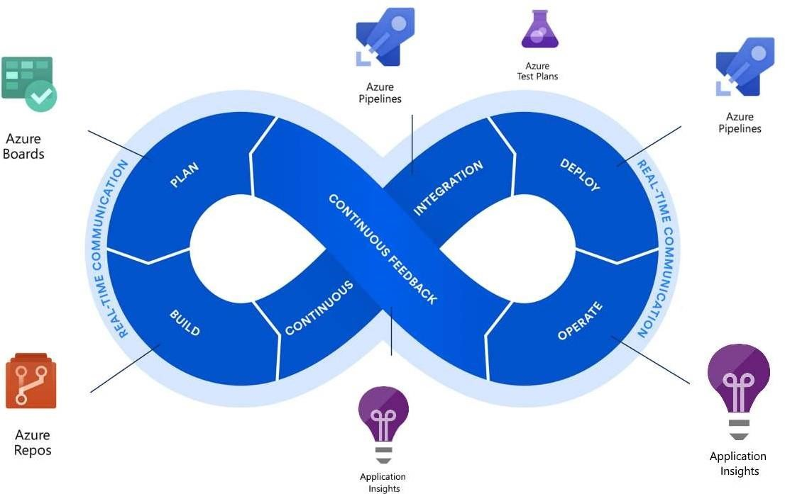

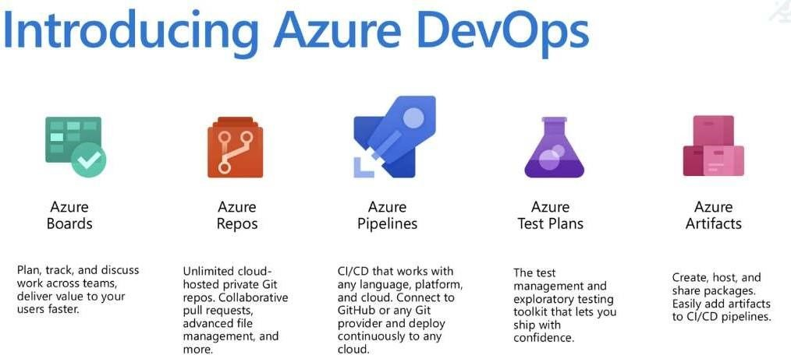

**Deep Dive into Azure DevOps Elements:**

You've already grasped the core elements of Azure DevOps – Boards, Repos, and Pipelines. Let's explore them further and introduce two additional components: Azure Test Plans and Azure Artifacts.

**Azure Boards:**

* **Think of it as your centralized task management and communication hub.**
* **Visualize workflows:** Create Kanban or Scrum boards to drag and drop tasks, reflecting your team's preferred methodology.
* **Work item management:** Track progress, assign tasks, collaborate on discussions, and generate reports for comprehensive project oversight.
* **Integrations:** Seamlessly connect with other Azure DevOps tools for a unified experience.

**Azure Repos:**

* **The secure home for your code and project assets.**
* **Unlimited private Git repositories:** Host your codebase and collaborate with your team using branching, pull requests, and code reviews.
* **Version control:** Track changes, revert to previous versions if needed, and maintain a clear history of your project's evolution.
* **Integrations:** Connect with Pipelines for automated builds and deployments based on code changes.

**Azure Pipelines:**

* **The automation champion for building, testing, and deploying your software.**
* **CI/CD pipelines:** Define automated workflows to build, test, and deploy code whenever changes are pushed to Repos.
* **Platform and cloud flexibility:** Build on various platforms and deploy to different cloud environments (including Azure, AWS, and GCP).
* **Testing automation:** Integrate with Azure Test Plans or other testing tools to ensure quality and catch bugs early.
* **Continuous delivery:** Enable smooth and frequent software updates with minimal manual intervention.

**Azure Test Plans:**

* **Your comprehensive toolkit for manual and exploratory testing.**
* **Test case creation:** Design test cases to cover various functionalities and scenarios.
* **Exploratory testing:** Facilitate ad-hoc testing sessions to discover hidden bugs and edge cases.
* **Test execution and tracking:** Run tests, track results, log defects, and monitor progress of your testing efforts.
* **Integrations:** Link test plans with Pipelines for automated test execution as part of your CI/CD process.

**Azure Artifacts:**

* **The package management haven for sharing and utilizing code components.**
* **Create and host various package types:** Manage NuGet, Maven, npm, and Python packages within your organization.
* **Package sharing:** Securely share packages with specific teams or projects, promoting code reuse and standardization.
* **Package feeds:** Organize packages efficiently with private and public feeds, ensuring controlled access and visibility.
* **Integrations:** Seamlessly integrate with Pipelines to leverage packages during your build and deployment workflows.

**What technologies do I need to support DevOps?**

DevOps brings together people, processes, and technology, automating software delivery to provide continuous  value to your users. Using Azure DevOps, you can deliver software faster and more reliably - no matter how big  your IT department or what tools you’re using.

Continuous Integration (CI)

* Improve software development  quality and speed.
* When you use Azure Pipelines or  Jenkins to build apps in the cloud and  deploy to Azure, each time you

commit code, it’s automatically built  and tested and bugs are detected  faster.

Continuous Deployment (CD)

* By combining continuous integration  and infrastructure as code (IaC), you’ll  achieve identical deployments and  the confidence to deploy to  production at any time.
* With continuous deployment, you can  automate the entire process from  code commit to production if your  CI/CD tests are successful.

Continuous Learning & Monitoring

* With Azure Application Insights you  can identify how your applications are  performing and test if the recent  deployment made things better or  worse.
* Using CI/CD practices, paired with  monitoring tools, you’ll be able to safely  deliver features to your customers as  soon as they’re ready.

**HANDS ON**

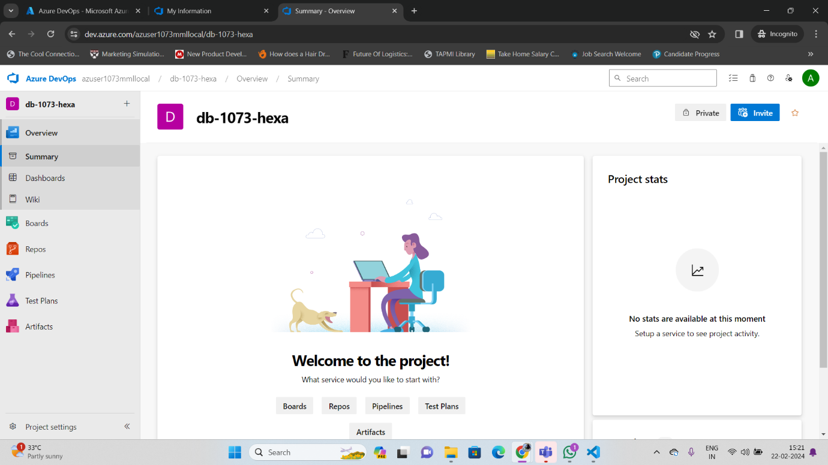

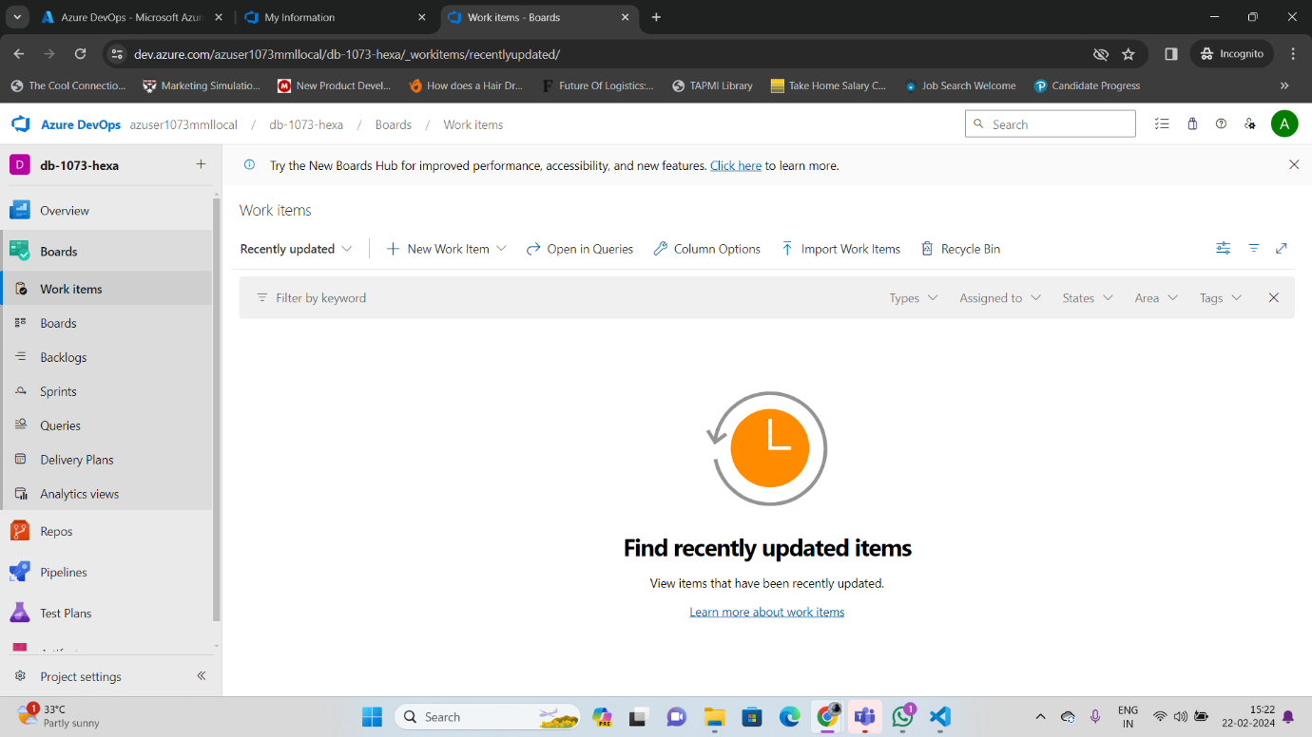

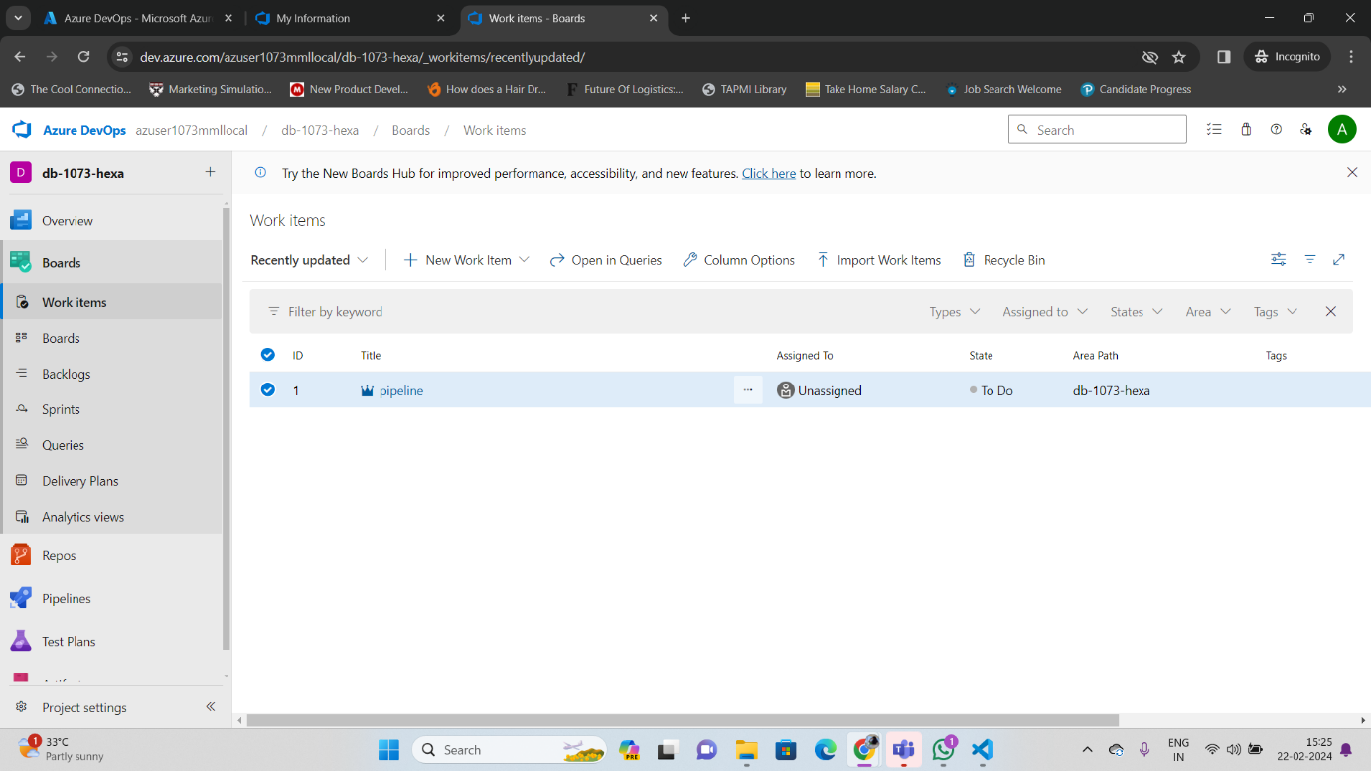

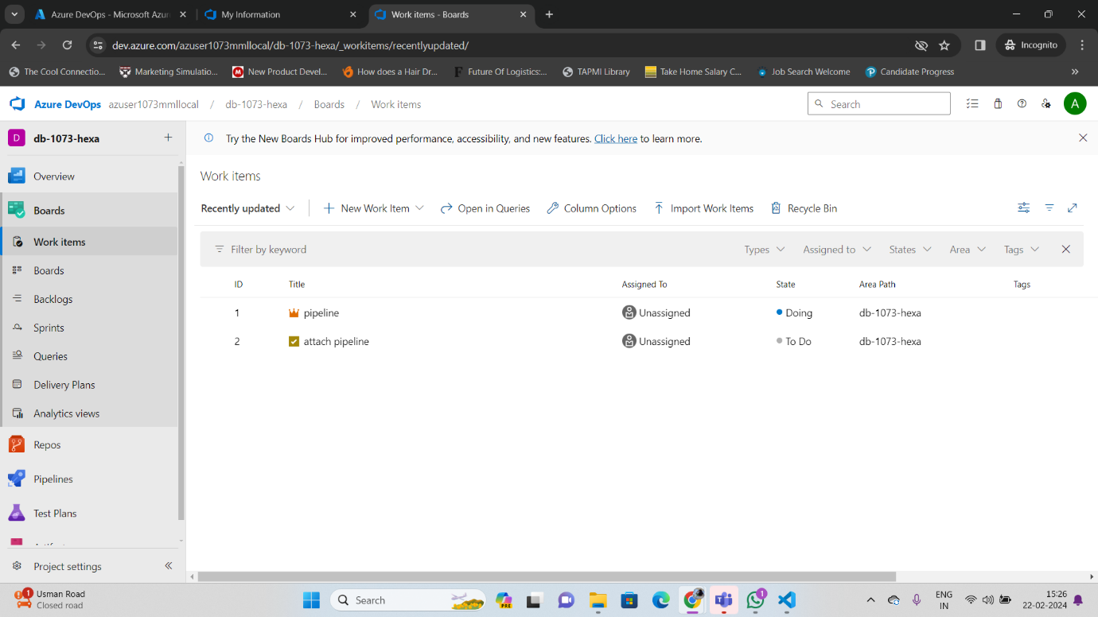

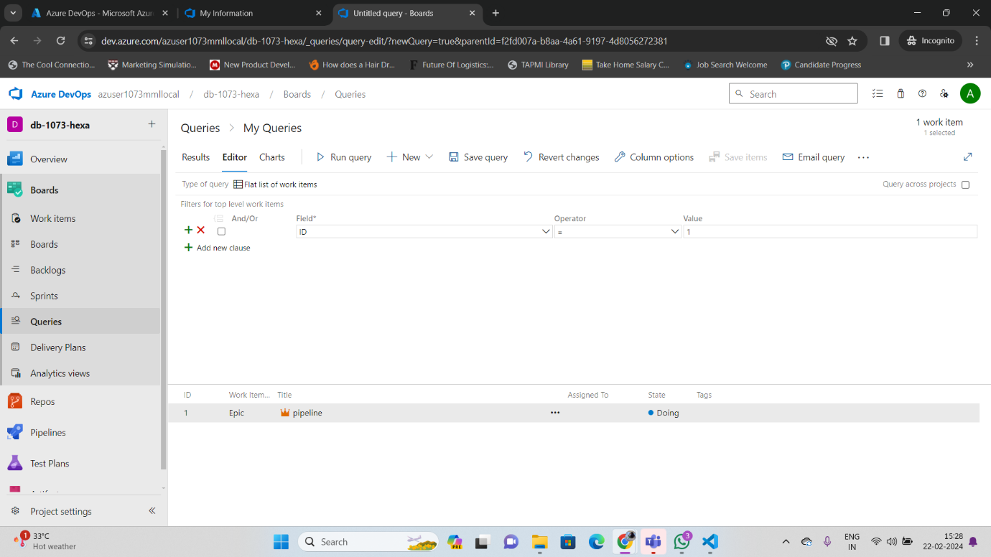

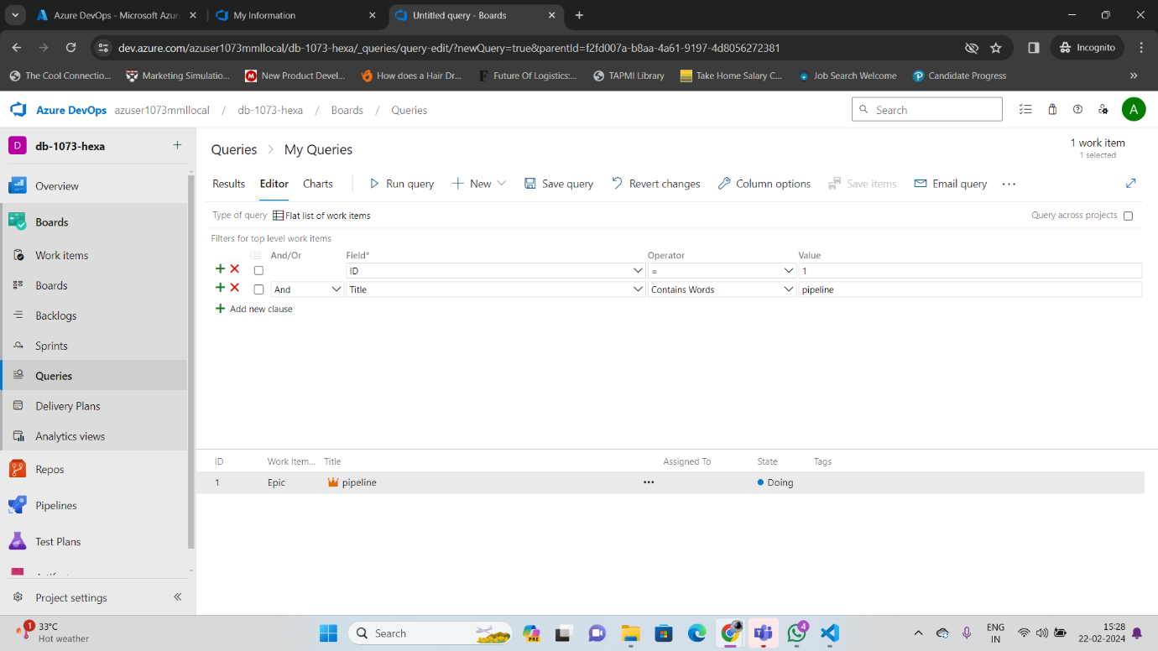

**Notes:**

